**LAB MANUAL**

**| ARTIFICIAL INTELLEGENCE**

**Lab – 43**



**Building user Interface using HTML, CSS for ML/DL Models**

**Implementation of HTML:**

**Objective:**

The objective of this lab is to Implement HTML concept and create a website: HTML Basic Components, List, Tables, Forms, Text formatting

**Equipment Required:**

1. Computer with internet access
2. Web Browser
3. VS Codre

**Prerequisites:**

1. Basic understanding of HTML
2. Familiarity with basic website development
3. Basic knowledge of using VS COde

**Problem Statement:**

* Build a website with these concept: HTML Basic Components, List, Tables, Forms, Text formatting

**Procedure:**

**Step By Step Process to complete all objectives:**

**Step 1: Setting Up the Project**

1. Create a new directory for your project.
2. Set name as smartphone price prediction

**Step 2: Basic HTML Structure**

Create an app.html file with the following structure:

<!DOCTYPE html>

<html>

<head>

<title>Smart-Phone Price Prediction</title>

</head>

<body>

<header>

<h1>Smart-Phone Price Prediction</h1>

</header>

<main>

<section id="description">

<p>Predict the price of a smartphone based on its features.</p>

</section>

</main>

<footer>

<p>&copy; 2024 Smart-Phone Price Prediction</p>

</footer>

</body>

</html>

#### Step 3: Lists

Add a div that uses lists to describe the features considered in the prediction model.

**Code:**

<div class="features">

                <h2>Features</h2>

                <ul>

                    <li>Brand</li>

                    <li>Model</li>

                    <li>Storage</li>

                    <li>Camera</li>

                    <li>Battery</li>

                </ul>

            </div>

#### Step 4: Tables

Create a table to show some example data.

            <div class="example-data">

                <h2>Example Data</h2>

                <table>

                    <tr>

                        <th>Brand</th>

                        <th>Model</th>

                        <th>Storage</th>

                        <th>Camera</th>

                        <th>Battery</th>

                        <th>Price</th>

                    </tr>

                    <tr>

                        <td>Brand A</td>

                        <td>Model X</td>

                        <td>64GB</td>

                        <td>12MP</td>

                        <td>3000mAh</td>

                        <td>$300</td>

                    </tr>

                    <tr>

                        <td>Brand B</td>

                        <td>Model Y</td>

                        <td>128GB</td>

                        <td>16MP</td>

                        <td>3500mAh</td>

                        <td>$400</td>

                    </tr>

                </table>

            </div>

#### Step 5: Forms

Create a form for users to input the features of their smartphone to predict the price.

<section id="prediction-form">

<h2>Predict the Price</h2>

<form action="/predict" method="POST">

<label for="brand">Brand:</label>

<input type="text" id="brand" name="brand"><br><br>

<label for="model">Model:</label>

<input type="text" id="model" name="model"><br><br>

<label for="ram">RAM:</label>

<input type="text" id="ram" name="ram"><br><br>

<label for="storage">Storage:</label>

<input type="text" id="storage" name="storage"><br><br>

<label for="camera">Camera:</label>

<input type="text" id="camera" name="camera"><br><br>

<label for="battery">Battery:</label>

<input type="text" id="battery" name="battery"><br><br>

<label for="screen_size">Screen Size:</label>

<input type="text" id="screen_size" name="screen_size"><br><br>

<input type="submit" value="Predict Price">

</form>

</section>

**Step 6: Put list div and table div into**  <div class="container"> </div>

#### Step 7: Text Formatting

Use text formatting tags to enhance the readability of your content.

<section id="description">

<p>Predict the price of a smartphone based on its <strong>features</strong>. Our model considers various factors such as <em>brand</em>, <em>model</em>, <em>RAM</em>, <em>storage</em>, and more.</p>

</section>

**Run app.html to the Web Browser**

**The complete code:**

**//Ignore**     <link rel="stylesheet" href="./style.css"> we will create it later

<!DOCTYPE html>

<html>

<head>

    <title>Smart-Phone Price Prediction</title>

    <link rel="stylesheet" href="./style.css">

</head>

<body>

    <header>

        <h1>Smart-Phone Price Prediction</h1>

    </header>

    <main>

        <section id="description">

            <p>Predict the price of a smartphone based on its <strong>features</strong>. Our model considers various factors such as <em>brand</em>, <em>model</em>, <em>RAM</em>, <em>storage</em>, and more.</p>

        </section>

        <div class="container">

            <div class="features">

                <h2>Features</h2>

                <ul>

                    <li>Brand</li>

                    <li>Model</li>

                    <li>Storage</li>

                    <li>Camera</li>

                    <li>Battery</li>

                </ul>

            </div>

            <div class="example-data">

                <h2>Example Data</h2>

                <table>

                    <tr>

                        <th>Brand</th>

                        <th>Model</th>

                        <th>Storage</th>

                        <th>Camera</th>

                        <th>Battery</th>

                        <th>Price</th>

                    </tr>

                    <tr>

                        <td>Brand A</td>

                        <td>Model X</td>

                        <td>64GB</td>

                        <td>12MP</td>

                        <td>3000mAh</td>

                        <td>$300</td>

                    </tr>

                    <tr>

                        <td>Brand B</td>

                        <td>Model Y</td>

                        <td>128GB</td>

                        <td>16MP</td>

                        <td>3500mAh</td>

                        <td>$400</td>

                    </tr>

                </table>

            </div>

        </div>

        <section id="prediction-form">

            <h2>Predict the Price</h2>

            <form action="/predict" method="POST">

                <label for="brand">Brand:</label>

                <input type="text" id="brand" name="brand"><br><br>

                <label for="model">Model:</label>

                <input type="text" id="model" name="model"><br><br>

                <label for="ram">RAM:</label>

                <input type="text" id="ram" name="ram"><br><br>

                <label for="storage">Storage:</label>

                <input type="text" id="storage" name="storage"><br><br>

                <label for="camera">Camera:</label>

                <input type="text" id="camera" name="camera"><br><br>

                <label for="battery">Battery:</label>

                <input type="text" id="battery" name="battery"><br><br>

                <label for="screen_size">Screen Size:</label>

                <input type="text" id="screen_size" name="screen_size"><br><br>

                <input type="submit" value="Predict Price">

            </form>

        </section>

        <section id="description">

            <p>Predict the price of a smartphone based on its <strong>features</strong>. Our model considers various factors such as <em>brand</em>, <em>model</em>, <em>RAM</em>, <em>storage</em>, and more.</p>

        </section>

    </main>

    <footer>

        <p>&copy; 2024 Smart-Phone Price Prediction</p>

    </footer>

</body>

</html>

**Output:**

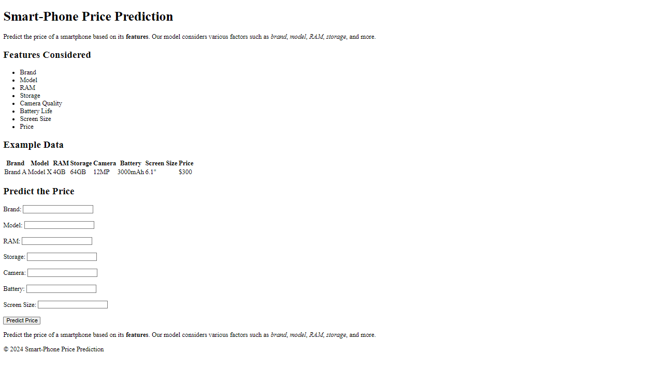

**Conclusion:**

By following this lab manual, you should be able to create a simple web application that integrates HTML concepts with a machine learning model for predicting smartphone prices. This exercise will help you understand the basics of web development while applying machine learning to a real-world problem.